VICTORIA JUNIOR COLLEGE
JC2 PRELIMINARY EXAMINATION 2024
H2 GEOGRAPHY PAPER 1

MARK SCHEME

Qn | Answer | Marks
1a | Explain how the Global Production Networks (GPNs) of TNCs like Ferrero Group connect places within the global economy.  Award 1 mark for each explanation of how the GPN of Ferrero Group connect places with the global economy.  Award a maximum of 1 additional mark for further development of each point, where applicable.  Possible responses include:  -TNCs like Ferrero Group require raw supplies/materials for its products and these inputs are often sourced from countries which produce such raw materials such as cocoa from Nigeria and sugar Brazil. [1]  -These raw materials are transported to the TNC’s factories/manufacturing plants in different parts of the world such as Canada and Germany to be transformed into finished products. [1]  -These finished products are then distributed to the sales offices in different parts of the world such as in the Americas, Asia and Europe. [1]  -These products are then consumed by the market globally. [1]  -There may also be different operations in different places or within the same country as seen in in France where we see the supply of raw materials and factories in the same country. [1]  AO1 | 5
1b | Suggest reasons for the spatial distribution of Ferrero Group’s GPN as seen in Resource 1.  Award 1 mark for each suggestion to account for the spatial distribution of Ferrero Group’s GPN.  Award a maximum of 1 additional mark for further development of each point, where applicable.  Possible responses include:  -Source of raw materials mostly located in LDCs, due to low costs of raw materials compared to DC counterparts which can offer the same raw materials [1]. This helps to reduce costs of production which is integral for a TNC. [1]  -Since the finished good is a food product, there is a need to locate factories in places which offer high skilled labour i.e. DCs to produce quality food that meet safety standards. [1]  OR  -There are factories in countries near the HQ in Italy where they can monitor the processes and maintain quality of product. [1]  OR  -Factories are located in LDCs since cost of operations are ow due to low labour costs which is integral for TNCs to lower costs of production. [1]  -Sales office in almost all regions to be near consumers to tailor/modify products to customers’ tastes and preferences. [1]  OR  -Sales office in almost all regions due to high global consumption of products, hence need to be close to consumers to ensure that products reach consumers quickly. [1]  AO1 | 5
1c | With reference to Resource 2, explain the impacts of Ferrero Group’s global production of Nutella.  Award 1 mark for each explanation of impacts of Ferrero Group’s global production.  Award a maximum of 1 additional mark for further development of each point, where applicable.  Possible responses include:  -Large-scale/high rates of deforestation to make way for oil palm plantation has affected/destroyed both flora and fauna which depended on the forests as their habitats are destroyed [1], resulting in animals such as orang utans to be endangered. [1]  -Deforestation has also resulted in the displacement of natives communities who were dependent on the forests as their source of livelihoods i.e. living spaces and daily necessities [1] hence, these communities will lose their sense of belonging/community/homelessness/migrate to an unknown environment. [1]  -The long term effect of deforestation is that the removal of trees has resulted in the loss of carbon sinks on a large scale and cause climate change/global warming in the long run. [1]  -The issue of child labour being used on hazelnut farms was another impact raised as children were exploited for economic purposes [1] which cut off their opportunities in schooling and healthcare. [1]  AO2 | 6
1d | Suggest how states can mitigate the impacts of Ferrero Group’s global production of Nutella.  Award 1 mark for each suggestion of how states can mitigate the impacts of Ferrero Group’s global production.  Award a maximum of 1 additional mark for further development of each point, where applicable.  Possible responses include:  -States can establish labour regulation [1]. This is to ensure that there is close monitoring and enforcement in labour standards in TNCs such as Ferrero Group to ensure that exploitation of child for labour does not take place [1]. States can also ensure that strict labour laws are implemented to ensure worker rights’ are not compromised such as fair wages [1].  - -States can enforce stricter laws to ensure the environment and people are unaffected by TNCs’ operations [1]. TNCs which violate the laws can be fined or have their operations discontinued [1]. States can also provide concessions/subsidies for TNCs which adhere to the laws [1].  AO1 | 4
1e | Compare the share of sales of Mars Inc and Ferrero Group in 2015 shown in Resource 3.  Award 1 mark for each description of the share of sales of the two confectionary companies.  Award a maximum of 2 marks for description of either similarity or difference only.  Possible responses:  -Difference: Highest sales of Mars Inc in North America (35%), highest sales of Ferrero Group in Western Europe (52%)  -Difference: Sales of Mars Inc in Asia Pacific higher than sales of Ferrero Group (6% points difference)  -Difference: Sales of Ferrero Group in Latin America higher than sales of Mars Inc (5% points difference)  -Difference: Sales of Ferrero Group in Eastern Europe higher than sales of Mars Inc (3% points difference)  -Difference: Sales of Mars Inc in Middle East and Africa higher than sales of Ferrero Group (4% points difference)  -Similarity: Both Mars Inc and Ferrero Group have the lowest sales in Australia (2% and 1% respectively)  -Similarity: Both Mars Inc and Ferrero Group have sales in all regions (at least 1% in all regions)  AO2 | 4
1f | With reference to Resource 3, account for Ferrero Group’s share of sales in North America and Western Europe.  Award 1 mark for each explanation for Ferrero Group’ sales numbers in North America and Western Europe.  Award a maximum of 1 additional mark for further development of each point, where applicable.  Possible responses include:  -Ferrero Group’s sales in Western Europe are high since the company’s country of origin is Italy, hence, much easier to conduct sales in Europe [1] since countries in Europe have a common standards and regulations for products and services across member states which makes doing business much easier [1].  -Ferrero Group’s sales in North America are low since they face long-standing competitors from other more established confectionary companies that were founded earlier than Ferrero Group [1], hence they have been in the market for long and have established a strong consumer base [1].  -Ferrero Group’s sales in North America are low since they face competitors from home grown confectionaries e.g. Mars Inc and Mondelez [1], due to a high trust in the local brand among consumers in North America [1].  AO2 | 6
2a | With the use of a well-labelled diagram, describe the features of the karst landscape shown in Resource 4.  Award 1 mark for well-labelled diagram with at least two features. Award 2 marks for further description of features identified.  Possible labels:  - Tower karst  - Karst plain  - Vegetation  - Roads/buildings/farmland  Possible descriptions:  - Consists of tower karsts which are steep sided and tall, towering above the karst plain [1]  - Tower karsts are isolated from one another with the karst plain in between them [1]  - Tower karsts are covered by vegetation [1] except on the vertical sides where there is exposed rock [1]  - Evidence of human development in the area with roads, buildings and farmland. [1]  Sample sketch:  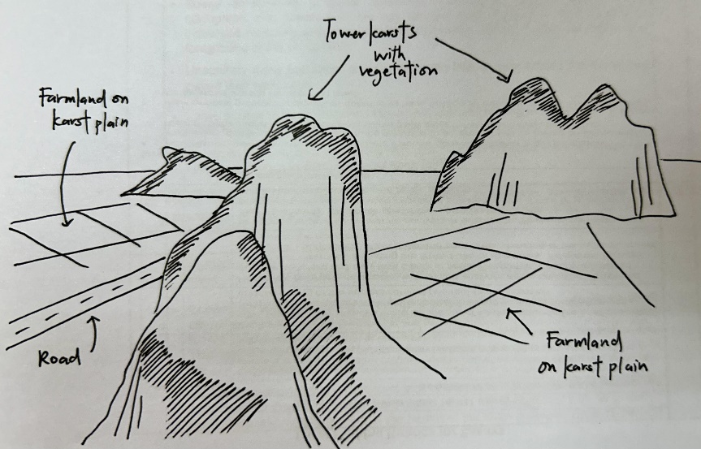  AO2 | 4
2b | With reference to Resource 5, account for the temperature characteristics of Kampot, Cambodia.  Award 1 mark for each point. Award a maximum of 1 additional mark for further development of each point, where applicable.  - High mean annual temperature of 26.5°C [1]  - Located at a low latitude of 10°N where the sun’s rays hit the earth at a higher angle of incidence. [1] This causes the sun’s rays to be concentrated on a small area, resulting in a greater intensity of radiation, and thus higher surface temperatures. [1]  - Small annual temperature range of 2°C. [1]  - Equator remains tilted towards the sun throughout the year leading to an absence of seasons, thus causing minimal temperature variation through the year. [1]  AO1 | 5
2c | With reference to Resource 4 and 5, explain why chemical weathering processes are likely to be dominant in this location.  Award 1 mark for each point. Award a maximum of 1 additional mark for further development of each point, where applicable. Students must refer to both Resource A and B.  - [Favourable climate]: As seen in Resource B, Kampot has an Am climate (tropical monsoon) with a high total annual precipitation of 1840mm. [1] The presence of water helps to facilitate chemical weathering processes, as water will react with CO₂ in the atmosphere and soil to form a weak carbonic acid that aids in solution/carbonation of limestone. [1] In addition, the high mean annual temperatures  of 26.5°C also speeds up the rate of chemical weathering. [1]  - [Vegetation]: As seen in Resource A, Kampot’s favourable climate has allowed the growth of lush vegetation in the karst landscape. [1] When the vegetation decomposes, they produce organic acids that increase the acidity of water, which further aids in chemical weathering. [1]  - [Geology]: As seen in Resource A, Kampot’s karst landscape consists of limestone rock which is highly susceptible to solution/carbonation [1], due to the calcium carbonate in limestone reacting with water to produce calcium bicarbonate, thus breaking down the rock. [1]  AO2 | 5
2d | Explain how the limestone cave in Resource 6 was formed.  Award 1 mark for each point. Award a maximum of 1 additional mark for further development of each point, where applicable.  - Atmospheric CO2 is dissolved in rainwater. When rainwater seeps into the soil, they absorb more CO2 and form a weak carbonic acid. [1]  - This water first enters the ground via individual fissures or sinkholes and flows along joints and bedding planes. [1]  - When the water encounters calcium carbonate in limestone, the bonds between the calcium and carbon atoms are broken, forming calcium bicarbonate which is soluble, thus dissolving the rock. [1] This process is known as solution/carbonation. [1]  - As the infiltrating water travels deeper into the rock through joints or bedding planes, it slowly creates cavities and gradually enlarges them into caves. [1]  AO1 | 5
2e | Describe the ecosystem services offered by karst landscapes in Cambodia as seen in Resource 6 and 7.  Award 1 mark for each point. Award a maximum of 1 additional mark for further development of each point, where applicable.  - Karst landscapes offer cultural ecosystem services as they contain caves that are used for religious purposes. [1] As seen in Resource C, a Hindu temple can be found in the Phnom Chhnork cave in Kampot where devotees can come to carry out rituals. [1] Resource D also describes that these caves are thought by locals to be homes to neak ta or landscape spirits, thus illustrating their religious and cultural significance. [1]  - Another cultural ecosystem service offered by karst landscapes is that they function as important educational and research sites. [1] Resource D illustrates that the landscape contains unique animal and plant life that cannot be found anywhere else, and that scientists are working to document rare plant life found in the landscape. [1]  - Karst landscapes offer provisioning ecosystem services in the form of raw materials. [1] As seen in Resource D, karst landscapes provide limestone which is being quarried by construction companies to produce cement. [1]  AO2 | 6
2f | With reference to Resource 7, describe how the ecosystem services of karst landscapes in Cambodia can be threatened by limestone quarrying.  Award 1 mark for each point. Award a maximum of 1 additional mark for further development of each point, where applicable. Students can refer to any karst landscape/human activity, even those not in the resources provided.  Possible points:  - The cultural ecosystem services of karst landscapes as an educational and research site can be undermined. [1] The widespread destruction of karst landscapes through blasting the rock to obtain limestone would threaten plant and animal life and even cause some species to go extinct. [1] This could lead to the loss of habitats would cause the landscape to lose its value as an educational and research site. [1]  - The provisioning services of karst landscapes in offering raw materials can be undermined. [1] The extensive quarrying of karst landscape would lead to it being rapidly depleted of limestone, which is a finite resource, and thus undermine its ability to offer such raw materials in the long run. [1]  AO2 | 5
3 | ‘Renewable energy sources are good alternatives to fossil fuels as energy sources.’ Evaluate this statement.  Possible Approaches:  Candidates could approach the question by making a judgment on whether renewable energy sources i.e. solar and hydropower are good alternatives to fossil fuels as energy sources. Candidates consider a set of criteria to compare the two energy sources such as cost of implementation or usage, reliability, long term sustainability, contribution to greenhouse emissions and other consequences due to its implementation e.g. deforestation, displacement of communities, sedimentation.  Levels marked using Generic Level Descriptors for 20m H2 essays.  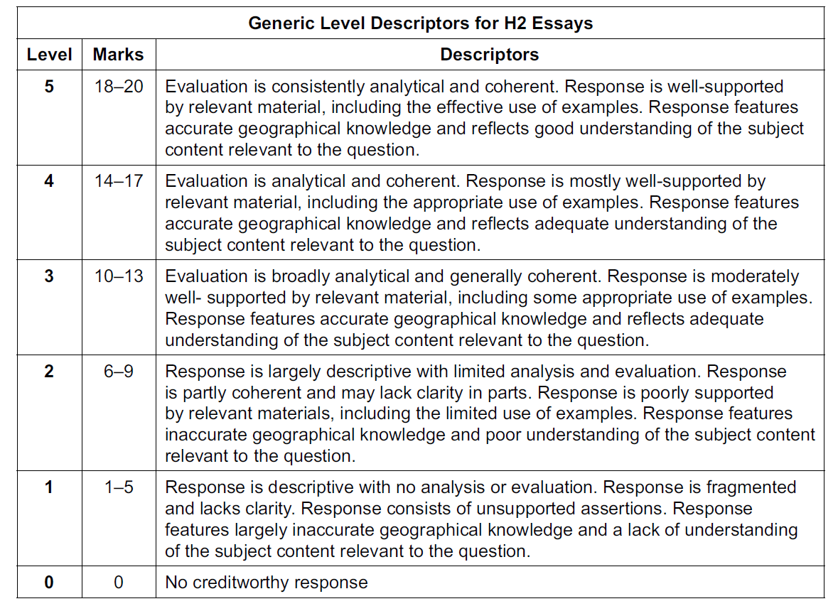 | 20
4 | ‘Strategies to manage conflicts over transboundary water resources are usually unsuccessful.’ Evaluate this statement.  Possible Approaches:  Candidates could approach the question by making a judgement on whether strategies used to manage conflicts over transboundary rivers have been successful or unsuccessful through a consideration of two or more case studies. Candidates could evaluate whether the strategies in each case study achieved the intended aims or targets. Candidates could also analyse the contextual factors such as availability of alternative water supplies and historical events, which may have contributed to the extent of success of the strategies. Candidates could also analyse the challenges to success which are common across the case studies.  Candidates could approach the question by making a judgement on whether some strategies have been more successful than others in managing conflicts over transboundary rivers through a consideration of criteria such as ability to bring about long-term resolution of the conflict and ability to address root causes of the conflict. Candidates could also analyse the difficulties in managing conflicts over transboundary rivers.  Levels marked using Generic Level Descriptors for 20m H2 essays. | 20
5 | Evaluate the influence of tropical cyclones on rainfall patterns in the tropics.  Possible Approach:  Candidates could approach the question by making a judgement on whether tropical cyclones have a significant influence on rainfall patterns in the tropics in comparison to other factors (e.g. shifting of ITCZ/Hadley Cell, ENSO, monsoons). Candidates should weigh the relative importance of these factors in influencing rainfall patterns (e.g. spatial and temporal scale) and come to a reasoned conclusion.  Levels marked using Generic Level Descriptors for 20m H2 essays.  AO3 | 20
6 | Evaluate the influence of natural factors on the shape and size of deltas.  Possible Approach:  Candidates could approach the question by making a judgement on whether natural factors (e.g. interaction between rivers/waves/tides, climate, geology) have a significant influence on the shape and size of deltas as compared to human factors (e.g. human activity such as the building of dams and levees, deforestation of mangroves). Candidates should weigh the relative importance of these factors (e.g. spatial and temporal scale) in influencing the ability of a delta to prograde (extend into the sea) and aggrade (grow in height) and come to a reasoned conclusion.  Levels marked using Generic Level Descriptors for 20m H2 essays.  AO3 | 20

Overview of AOs (guidelines in brackets)

 | AO1 (25m) | AO2 (35m) | AO3 (40m)
1(a) | 5
1(b) | 5
1(c) |  | 6
1(d) | 5
1(e) |  | 4
1(f) |  | 5
2(a) |  | 4
2(b) | 5
2(c) |  | 5
2(d) | 5
2(e) |  | 6
2(f) |  | 5
3 or 4 |  |  | 20
5 or 6 |  |  | 20
Total | 25 | 35 | 40

